**1.**

#include <stdio.h>

int main() {

int arr[100];

int n, i;

printf(“Enter the number of elements: “);

scanf(“%d”, &n);

printf(“Enter %d elements:”, n);

for (i= 0; i < n; i++) {

scanf(“%d”, &arr[i]);

}

printf(“The elements of the array are:\n”);

for (i = 0; i < n; i++) {

printf(“%d “, arr[i]);

}

return 0;

}

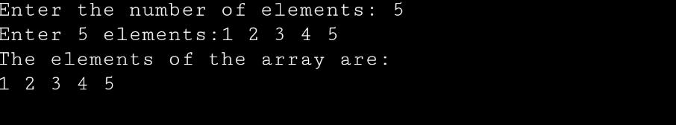

**2.**

#include <stdio.h>

int main() {

int arr[100];

int n, i;

printf(“Enter the number of elements: “);

scanf(“%d”, &n);

printf(“Enter %d elements:”, n);

for (i = 0; i < n; i++) {

scanf(“%d”, &arr[i]);

}

printf(“The reverse order of array elements:\n”);

for (i = n-1; i>=0; i--) {

printf(“%d “, arr[i]);

}

return 0;

}

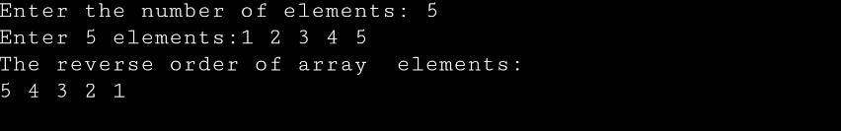

**3.**

#include <stdio.h>

int main() {

int arr[100];

int n, i,sum=0;

printf(“Enter the number of elements: “);

scanf(“%d”, &n);

printf(“Enter %d elements:”, n);

for (i = 0; i< n; i++) {

scanf(“%d”, &arr[i]);

}

for (i=0; i<n; i++) {

sum+=arr[i];

}

printf(“The sum of array elements:%d”,sum);

return 0;

}

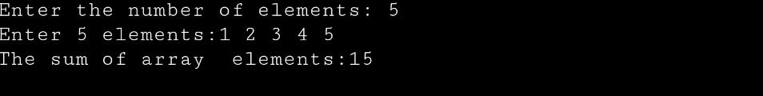

**4.**

#include <stdio.h>

int main() {

int arr[100];

int n, i, j, count = 0;

printf(“Enter the number of elements: “);

scanf(“%d”, &n);

printf(“Enter %d elements:\n”, n);

for (i = 0; i < n; i++) {

scanf(“%d”, &arr[i]);

}

for (i = 0; i < n – 1; i++) {

for (j = i + 1; j < n; j++) {

if (arr[i] == arr[j]) {

count++;

break;

}

}

}

printf(“Total number of duplicate elements: %d\n”, count);

return 0;

}

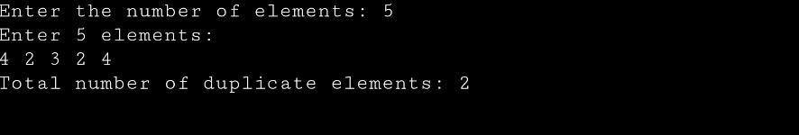

**5.**

#include <stdio.h>

int main() {

int arr[100], n, i, j, unique;

printf(“Enter the number of elements: “);

scanf(“%d”, &n);

printf(“Enter %d elements:\n”, n);

for (i = 0; i < n; i++) {

scanf(“%d”, &arr[i]);

}

printf(“Unique elements in the array are:\n”);

for (i = 0; i < n; i++) {

unique = 1;

for (j = 0; j < I; j++) {

if (arr[i] == arr[j]) {

unique = 0;

break;

}

}

if (unique) {

printf(“%d “, arr[i]);

}

}

printf(“\n”);

return 0;

}

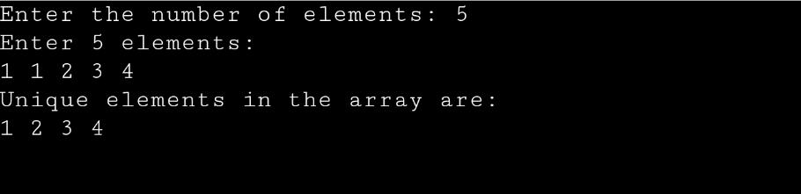

**6.**

#include<stdio.h>

int main() {

int arr[100], n, I, x, pos;

printf(“Enter the number of elements in the array: “);

scanf(“%d”, &n);

printf(“Enter the elements:\n”);

for (i = 0; i < n; i++) {

scanf(“%d”, &arr[i]);

}

printf(“Enter the element to be inserted: “);

scanf(“%d”, &x);

printf(“Enter the position where the element is to be inserted: “);

scanf(“%d”, &pos);

for (i = n – 1; i >= pos – 1; i--) {

arr[i + 1] = arr[i];

}

arr[pos – 1] = x;

n++;

printf(“Array after insertion:\n”);

for (i = 0; i < n; i++) {

printf(“%d “, arr[i]);

}

printf(“\n”);

return 0;

}

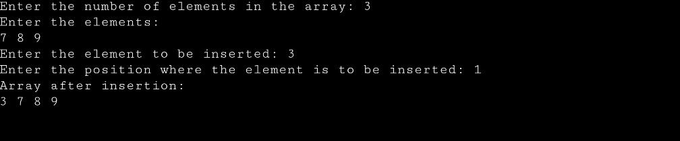

**7.**

#include <stdio.h>

int main() {

int arr[100], n, i, index;

printf(“Enter the number of elements: “);

scanf(“%d”, &n);

printf(“Enter the elements:\n”);

for (i = 0; i < n; i++) {

scanf(“%d”, &arr[i]);

}

printf(“Enter the index of the element to be deleted: “);

scanf(“%d”, &index);

for (i = index; i < n – 1; i++) {

arr[i] = arr[i + 1];

}

n--;

printf(“Array after deletion:\n”);

for (i = 0; i < n; i++) {

printf(“%d “, arr[i]);

}

printf(“\n”);

return 0;

}

